A young girl named Lily, wearing a cute pink dress with white sneakers, and her hair in two pigtails. She has a sweet, gentle personality and loves helping others. She’s kind-hearted, creative, and always looking out for her friends.

A young girl named Lily, wearing a cute pink dress with white sneakers, and her hair in two pigtails. She has a sweet, gentle personality and loves helping others. She’s kind-hearted, creative, and always looking out for her friends. Lily wakes up, stretches, and says happily, "A new day has begun!" She learns to make her bed by herself.

**Scene 1: The Morning Sun**  
Lily wakes up, stretches, and says happily, "A new day has begun!" She learns to make her bed by herself.

**Scene 2: Brushing Teeth is a Good Habit**  
Lily goes to the bathroom, picks up her toothbrush, and carefully brushes her teeth. "Brushing every day keeps my teeth healthy!" she says with a smile.

**Scene 3: Tidying Up Her Room**  
Lily notices her room is messy. She decides to put her toys back in the box and her books on the shelf. Now her room is clean, and she feels happy!

**Scene 4: A Healthy Breakfast**  
Mom prepares a nutritious breakfast. Lily eats fruit, milk, and bread, knowing that a healthy breakfast gives her energy for the day.

**Scene 5: Being on Time for School**  
Lily puts on her backpack and leaves for school on time. She learns that being punctual is important, and her teacher praises her for it!

**Scene 6: Helping a Friend**  
At school, Lily sees her friend drop a pencil. She quickly picks it up and hands it back. "Thank you!" her friend says with a big smile. Lily feels happy to help.

**Scene 7: Sharing is Joyful**  
At lunchtime, Lily shares her cookies with her friends. Everyone enjoys eating together, and the food seems even tastier!

**Scene 8: Paying Attention in Class**  
During the lesson, Lily listens carefully to the teacher and does her writing neatly. She realizes that learning can be really fun!

**Scene 9: Homework First, Then Play**  
After school, Lily finishes her homework before playing. She learns that doing important tasks first makes playtime even more enjoyable.

**Scene 10: Good Night, Lily!**  
It's bedtime. Lily takes a bath, listens to a bedtime story from Mom, and falls asleep peacefully, ready for another great day!

Imagel1.

Lily 起床了，伸個大懶腰，開心地說：「新的一天開始了！」她學習自己整理床鋪。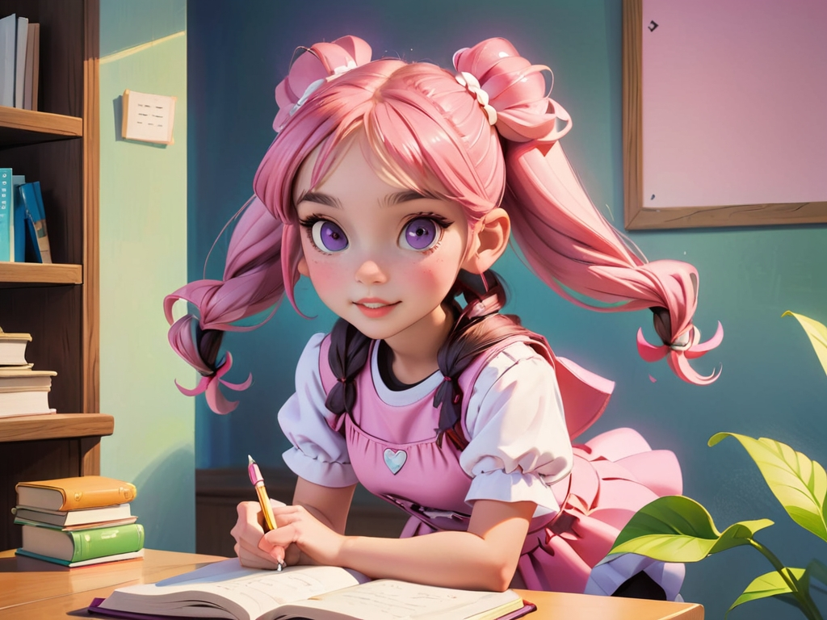

Imagle2.

Lily 走進浴室，拿起牙刷，仔細刷牙。「每天刷牙，牙齒才會健康！」她開心地笑了。

Imagle3. 媽媽準備了營養早餐，Lily 吃著水果、牛奶和麵包，知道健康的早餐讓她更有精神。



Imagle4.

在學校，Lily 看見朋友掉了鉛筆，立刻幫忙撿起來。朋友笑著說：「謝謝你！」Lily 感覺很快樂。

Imagle5.

放學回家，Lily 先寫完功課，再去玩耍。她學會了先完成重要的事情，這樣就能安心玩耍。

Imagle6.

午餐時間，Lily 把餅乾分給朋友們一起吃，大家開心地分享，美味變得更多了！

Imagle7.

睡覺時間到了，Lily 洗好澡、聽媽媽講故事，然後甜甜地進入夢鄉，準備迎接美好的一天！



Imagle8.

上課時，Lily 認真聽老師講課，寫字時不馬虎，她發現學習變得更有趣了！

Imagle9.

Imagle10.